NEW LIGHT-RING PCB

- PARTS:

QUANTITY: PART #: NOMENCLATURE: LENGTH:

1 PER MACHINE 217007-1 PCB, BLANK, NEW LIGHT-RING N/A

15 PER MACHINE 18721- LED, HIGH POWER, WIDE ANGLE N/A

1 PER MACHINE 17550-2 HEADER, RIGHT ANGLE, 2-PIN N/A

3 PER MACHINE 15126- RESISTOR, 120Ω, ½W, 5% N/A

- ASSEMBLY:

- INSERT AND SOLDER THE THREE RESISTORS, ACCORDING TO DIAGRAM 1.

- INSERT AND SOLDER THE HEADER, ACCORDING TO DIAGRAM 1.

- INSERT AND SOLDER THE LEDS, ACCORDING TO DIAGRAM 1.

NOTE 1
MAKE SURE THE RESISTORS ARE INSERTED SO THAT THE FIRST BROWN STRIPE IS TO THE RIGHT-SIDE.

NOTE 2
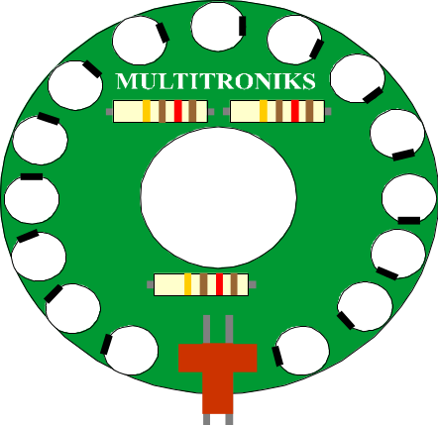MAKE SURE THAT THE LEDS ARE INSERTED WITH THE FLAT EDGES IN ACCORDANCE WITH DIAGRAM 1. ANY VARIATION MAY CAUSE OPERATIONAL FAILURE OR DAMAGE TO THE CIRCUITRY.

DIAGRAM 1

